MICRA Dashboard – The resident will see the “Announcements” that will give preview to the residents. Below, there is an Emergency Hotline, Announcement, Add Report, and View Report.

If the resident clicks the “Waste Report, Infrastructure Report , Crime Report ”, it will lead here, and the resident will see the application form after face validity.

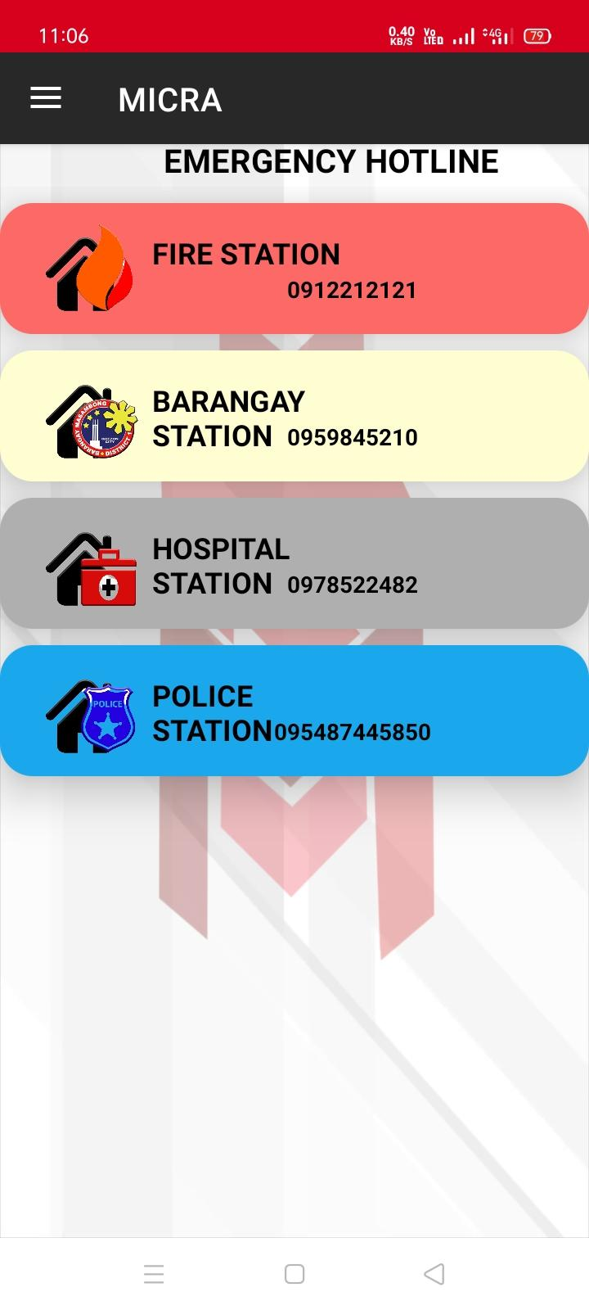

Once the residents select “Emergency Hotline” they can see the compiled list of emergency numbers for the reference of Barangay Masambong.

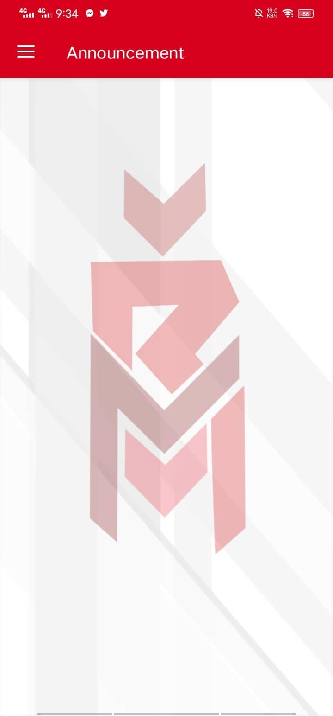

Once the residents select “Announcement” they can see the compiled list of announcements of Barangay Masambong.

The Resident - Once you click the Waste report, Infrastructure report, or Crime Report button, you must align your face to ensure the validity of your report before proceeding.

The resident must fill out an application, provide personal information, and indicate which concerns they have before submitting their application.

The resident will have to provide a picture for evidence, name, contact details, address and descriptions.

The resident must fill out an application, provide personal information, and indicate which concerns they have before submitting their application.

The resident will have to provide a picture for evidence, name, contact details, address and descriptions.